Name:M.Pavan Kiran

Trainer Name: Harshee Pithroda

Date:06-06-2022

1)Write a python program to print a table.

A)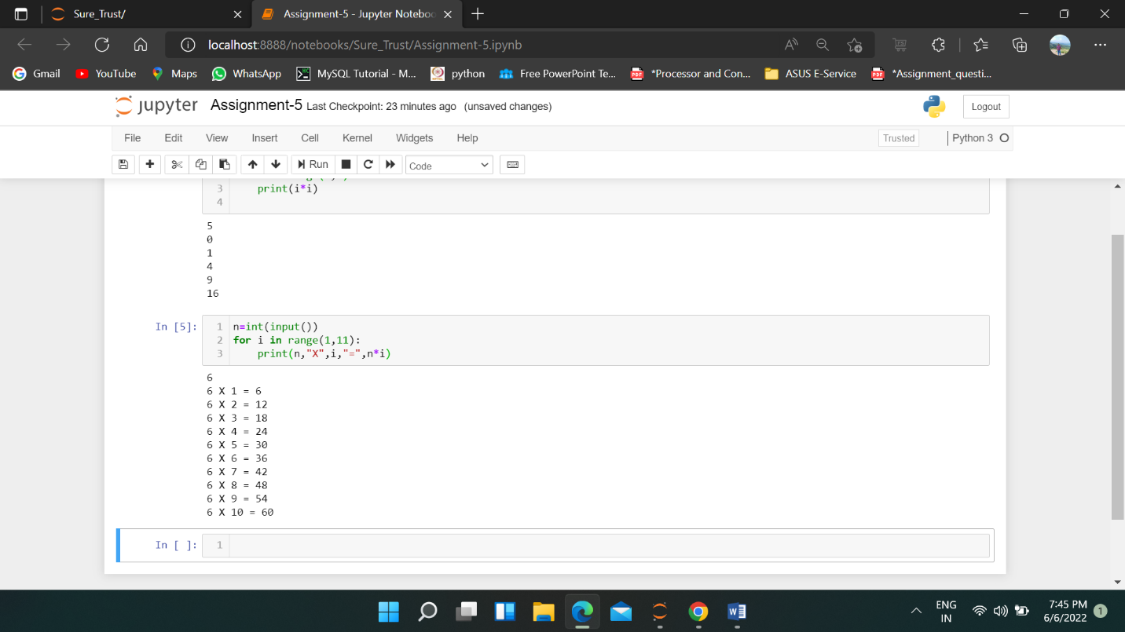

2) <https://www.hackerrank.com/challenges/python-loops/problem>.

Sol) n = int(input())

for i in range(n):

        print(i*i)

3) <https://www.hackerrank.com/challenges/py-if-else/problem?isFullScreen=false>

Sol)

import math

import os

import random

import re

import sys

if __name__ == '__main__':

    n = int(input().strip())

if n%2==0:

    if(n>=2 and n<=5):

        print("Not Weird")

    elif (n>=6 and n<=20):

        print("Weird")

    elif (n>=20):

        print("Not Weird")

    else:

        print("Unknown")

else:

    print("Weird")

  4) <https://www.hackerrank.com/challenges/whats-your-name/problem>

Sol) def print_full_name(first, last):

    print("Hello"+" "+first_name+" "+last_name+"!"+" "+"You just delved into python.")

if __name__ == '__main__':

    first_name = input()

    last_name = input()

    print_full_name(first_name, last_name)